S/w Download Issue Pseudo code

1. Open Service Now.
2. On the left hand side search bar type “Run” and open the “View/Run” report.
3. Click on the saved incident report.
4. List of all the open incidents will be available. Search the short description column for “Software - Download issue (reported through MyTech)”.
5. Open the incident.
6. Get the user’s sso from the “caller” field and the product name and product import id from the description field.
7. Open SmartTrack application.
8. Go to Processes🡪Requests🡪Active Requests screen.
9. In the “Account” column, enter the user’s sso and in the “Import Id (Product)” column enter the product import id and check for user’s request.
10. If the request is not found then take one of the below action and Exit.
11. Notify the SGL user and add comment on INC (Don’t resolve INC).
12. If the request is found then check the status of the request using the “Request Status” field in the Active request screen. Below can be the different statuses of request and their corresponding action.
13. Having keyword “Rejected”: Notify the user regarding it via mail and also update the same on the “Add Comment” field on the incident and close the incident by clicking on “Resolve Incident”.
14. All other statuses are “Open” except the request status having keywords Rejected or Closed:

Notify the user and SGL regarding that the request is still in progress and will be completed at the earliest via mail and also update the same on the “Add Comment” field on the incident and click “Save”.

1. Closed: Check “Installed” column in “Active Request” screen.
2. If “Installed” is “-” then Put “We are waiting for the license key from vendor” in “Add Comment” field and Change INC status to “Pending Third party” and click save. Exit.
3. If “Installed” is “x” continue with Step 12.
4. Go to Licenses🡪Licenses🡪Effective Licenses screen in SmartTrack.
5. In the “Assigned to user” field search the user’s sso and get all the licenses assigned to the user.
6. If licenses are found continue to step 14.
7. If no license is found continue to step 15.
8. In the “Assigned to request” column of the result set, need to identify the request number and match with the user’s request number (Batch ID column in the Active request screen).
9. If the request number is found then continue with step 17.
10. If the request number is not found then check the “Product Name (Product)” column in the Effective License and Active Request screens and match it. You can either find exact match or a similar match.
11. If desired license is found then go to step 17.
12. If desired license is not found then go to step 15.
13. If the license is not found then go to Licenses🡪Licenses🡪Expired Licenses screen.
14. In the “Order number” column search the order number of the request (Order number column in the Active request screen).
15. If licenses are found then search for the requested product name in the “Product Name (Product)” column. If match is found then notify the user that license is expired and new request needs to be raised for the software via mail and also update the same on the “Add Comment” field on the incident and close the incident by clicking on “Resolve Incident”.
16. If no record is found then notify the SGL user to check and take necessary action via mail and Exit.
17. If the desired license record is found then check the data from the “License Key” column.
18. If license serial key is found then save it temporarily and go to step 19.
19. If license serial key is not found then go to step 18.
20. Go to the box location. Open the license key file.
21. Search for the Request number and if request number is found then save license serial key temporarily and go to step 19.
22. If request number is not found then search using Order number and product import id. If license serial key is found save temporarily and go to step 19.
23. If no record is found continue with Step 19.
24. Copy “License pool key” from request screen and Go to “Process-> License Pools-> License Pools” Search based on “License pool key” in column “Key”.
25. If “License pool key” is found continue with step 20.
26. If “License pool key” is not found go to step 23(Should go to Step 23.c).
27. Check the value of “Delivery Method” column
28. If data is “Appdepot” then no action needed and go to Step 23.
29. If data is anything other than “Appdepot” then go to Step 21.
30. Go to the box location and open the Installation instruction file.
31. Search based on the PRID (Assumption/Tentative).
32. If found then save the installation instruction temporarily continue with Step 23.
33. If no record is found continue with Step 23.
34. Check the values for “License Key” and “Delivery Method”
35. If “License Key” is not found and “Delivery Method” is “Appdepot”, attach the word file “Create Appdepot ServiceNow Helpdesk” in the Incident close the incident by clicking on ‘Resolve’ add the close notes as per the “Close notes.txt”



1. If “License Key” is found and “Delivery Method” is “Appdepot” attach the word file “Create Appdepot ServiceNow Helpdesk” in the Incident, add the license key in the “Add comment” section then close the incident by clicking on ‘Resolve’ add the close notes as per the “Close notes.txt”.
2. If “License Key” is not found and “Delivery Method” is not “Appdepot” and installation instruction is found, then Notify SGL user via mail to take necessary action and provide user installation to the user update comments “Installation instruction provided” on the INC and click on “Save”.
3. If “License Key” is not found and “Delivery Method” is not “Appdepot” and installation instruction is not found, then Notify SGL user via mail to take necessary action and update comments “Informed the SGL Team via mail.” on the INC and click on “Save”.
4. If “License Key” is found and “Delivery Method” is not “Appdepot” and installation instruction is found, then provide license key and installation instruction to the user. Close the INC by clicking on “Resolve”.

# SCREEN PRINTS:

Open Service Now.

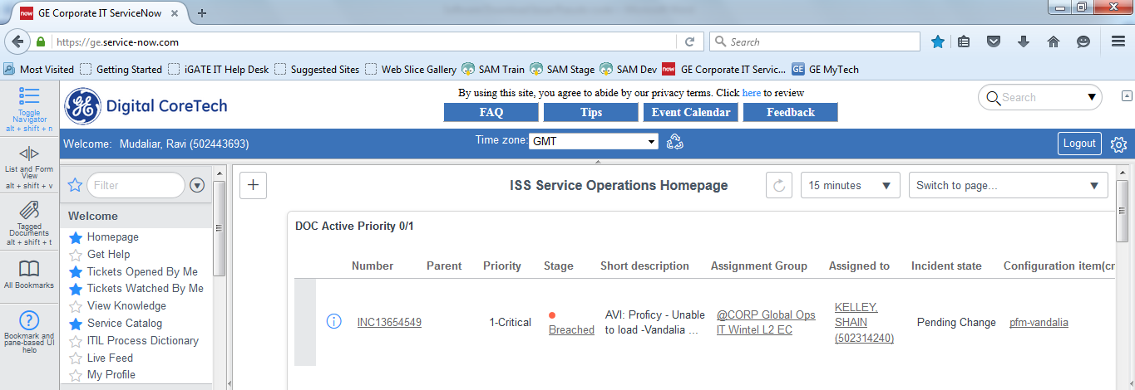

Search Run and click on View/Run.

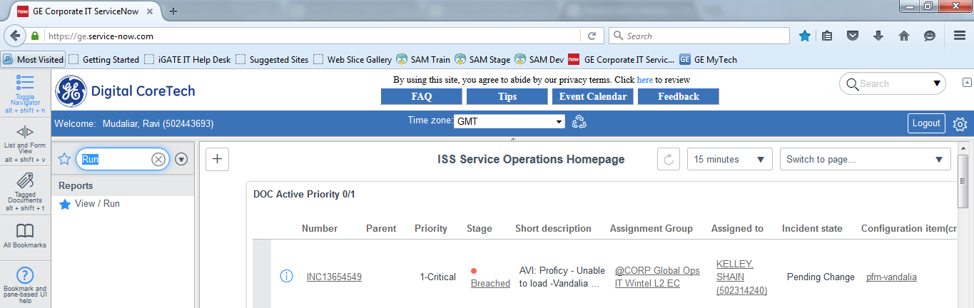

Click on the saved incident report.

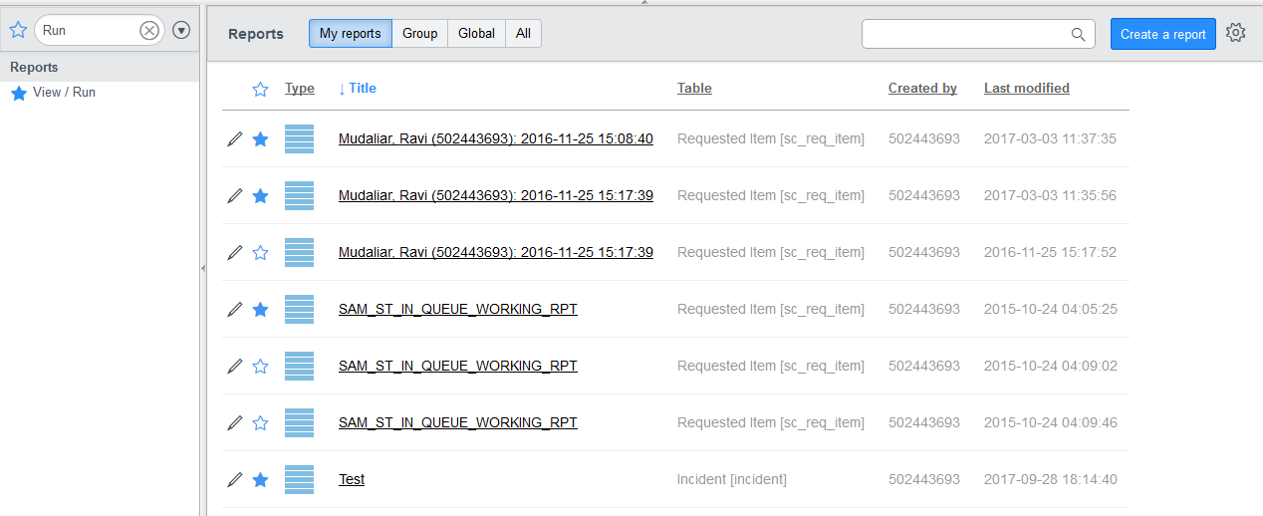

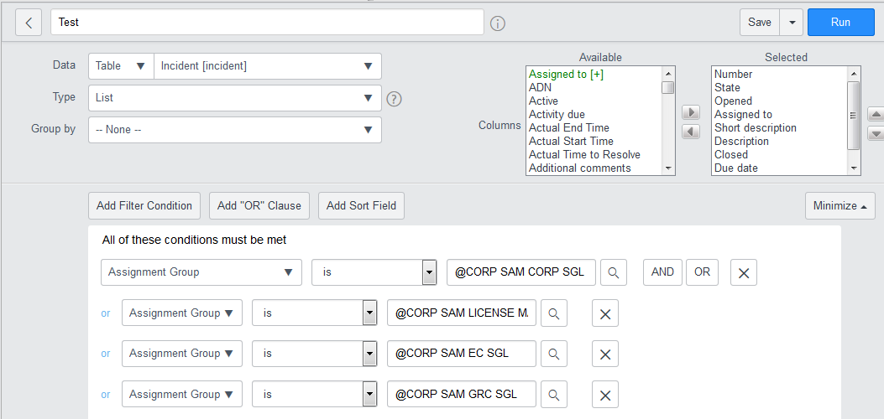

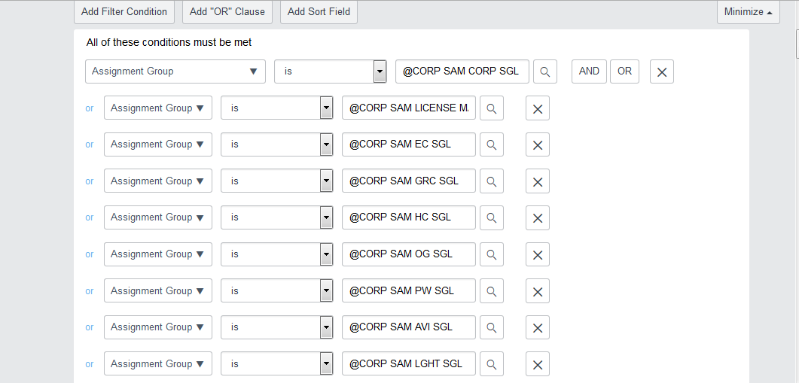

State: New, In Progress or Active

Short Description: Software - Download issue (reported through MyTech)

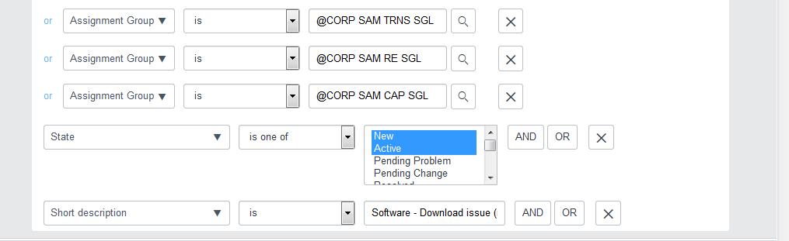

Caller Details

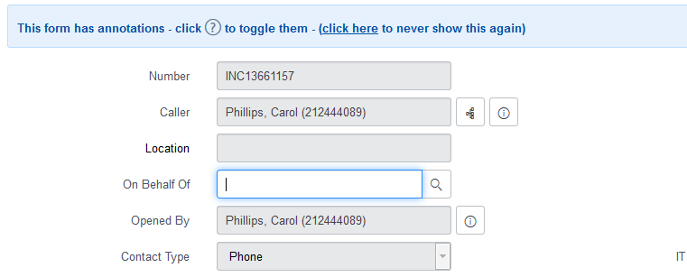

Description:

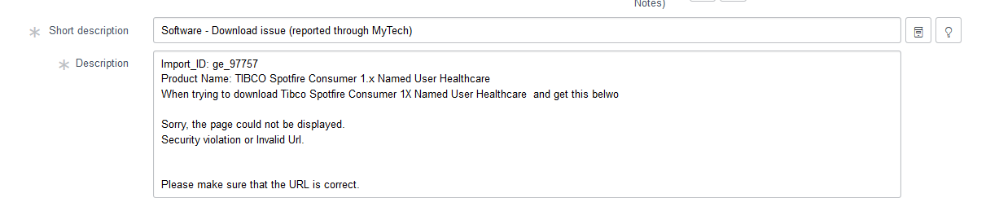

Open SmartTrack:

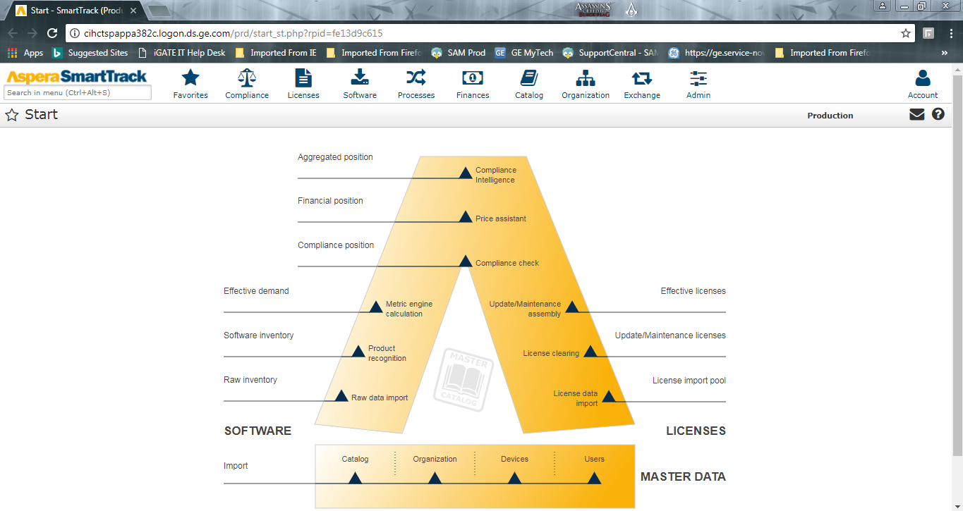

Active Request Screen: Search by user’s sso and product import id.

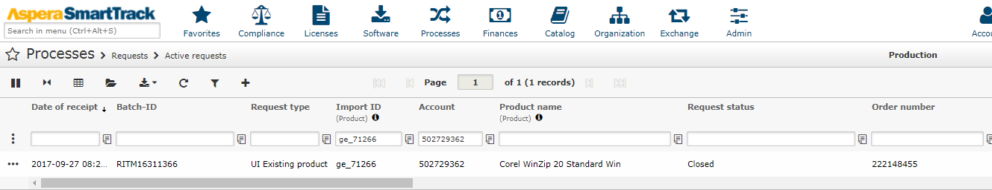

Effective License Screen: Search by user’s sso.

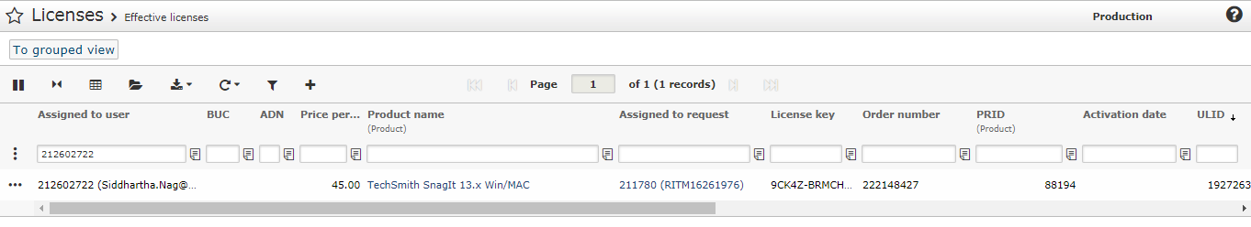

Expired License Screen: Search by order number.

